Connecting to MS Azure

MS Azure 1
Creating your Account 1
https://azure.microsoft.com/en-us/free/students/ 1
Creating your Database 1
Servers 2
Databases 2
Tables 2
Stored Procedures 2
Managing your Database 2
Using the Web Portal 3
Creating your Database 3
Using Visual Studio as the Database Owner 10
Checking the Connection 12
Accessing the Database for Other Team Members 14
Creating Tables 16
Adding Data 20
Creating Stored Procedures 25
Testing the Stored Procedure 27
Using the DataConnection 28
clsDataConnection 31
Creating the Data Connection Class File 31
Azure Connect 34
Connection Strings and Public Git Repositories 35

MS Azure
As a student you have access to a (sort of) free Azure account. The idea is that you are given $100 of credits which following these example should easily last you a year.
I would suggest that in your team you nominate one person who is going to be the account holder. It is on their account that the server and database needs to be created, it is their ID and password that needs to be distributed around the team so that each member has access to the database.
Azure is a platform that allows you to publish web applications and services running under a range of different technologies.
For this work we will concentrate solely on using Azure to provide back end database functionality.
Working as a team, Azure provides the big advantage that each team member may connect to and use the database simultaneously. In other alternative configurations there is the risk of having multiple copies of the same data (one database for each team member) along with the risk of locking all members out of the system while one person is editing the schema.
Being a web based service Azure is also available wherever you have access to the internet rather than say only being available on campus.

Creating your Account
Your first task will be to sign up for your student account. Make sure when you do this you use your University email address.
Azure is available here...

https://azure.microsoft.com/en-us/free/students/

I would suggest that one team member takes on the role of owning the account. Given that you will need to share your password with your team members I would suggest that you do not use a password that you are using for all other accounts!

Creating your Database
Once you have created your student account you should find yourself at something like the following page...
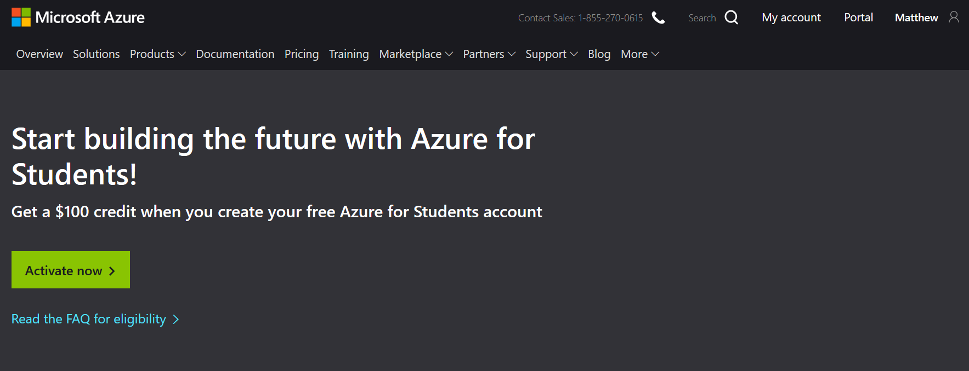
To set up servers and databases you need to manage your resources via the Azure portal...
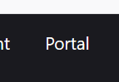

Servers
In order to make this work you will need to create a few resources to host your database.
The first resource you will need to configure is a server. A server is a computer (at Microsoft) that will host your database files(s).
The server can be called whatever you like so long as the name hasn’t already been taken.
You will set up a username and password for the server which your applications will need to provide to access the databases it hosts.

Databases
The database is a named data store which will contain your tables and stored procedures for managing your data.

Tables
Tables will store the raw data for your system.

Stored Procedures
Stored procedures will contain code written in SQL allowing you to manipulate the data in your tables. All interactions with the data will be via stored procedures and never by directly accessing the tables.

Managing your Database
There are three different systems we need to configure in order to access your database, they are...
- The Web Portal – for creating the server and database
- Visual Studio – for creating and managing tables, stored procedures
- Data Connection Class – allowing your code to access the functionality provided by your stored procedures

Using the Web Portal
The web portal is available on-line at https://azure.microsoft.com
The web portal is used mainly for setting up the server, creating your database and also managing firewall rules allowing your local machine to access the server.

Creating your Database
From the main page of the portal select the option Create a resource...
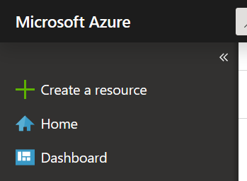
Find the section for SQL Database and click it...
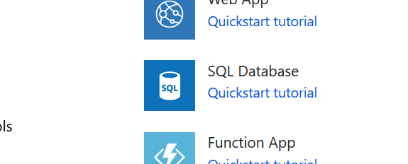
You now need to decide on the name of your server and the name of the first database, it is best to agree this as a team with one member hosting the server.
The first section of the form allows you to check that you have the right subscription set up and also selecting the resource group to use...
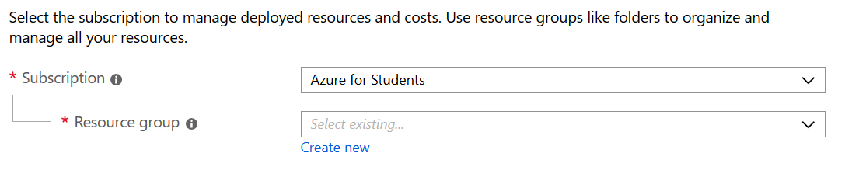
For resource group you may find that “MyResourceGroup” is already on the drop down list, if so select it, if not create it.
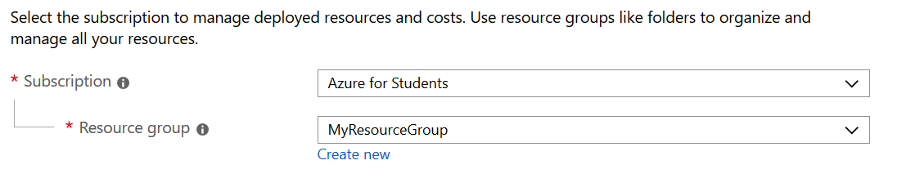
The next section allows us to set the name of the database and the name of the server. In this case we shall set the database to AddressBook and you need to decide on a suitable name for your server by selecting “create new”.
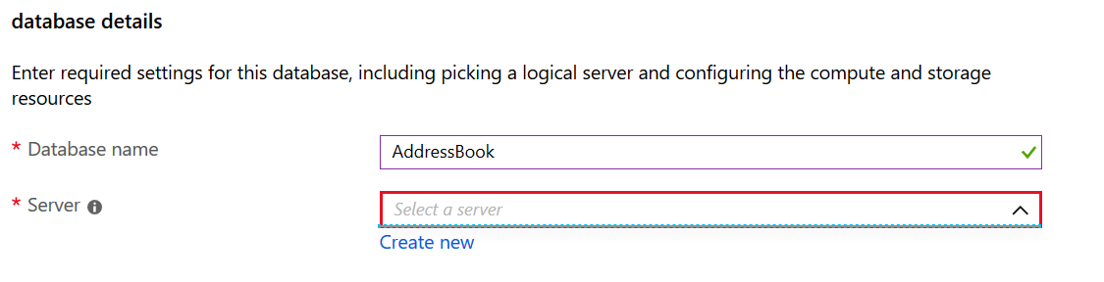
This will then ask you to complete the following options...
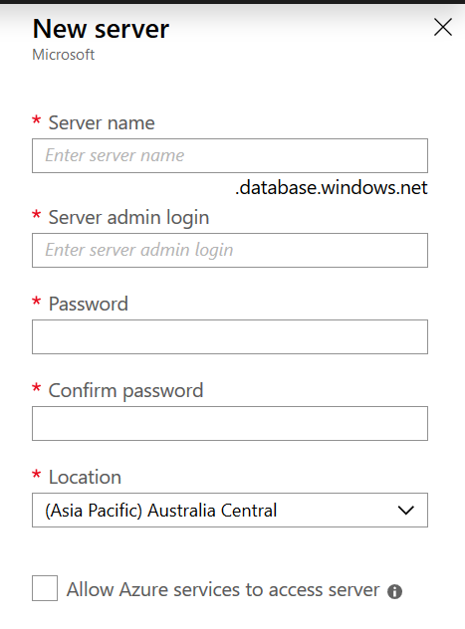
Complete the entries and make sure you keep a note of them passing the details to all members of your team.
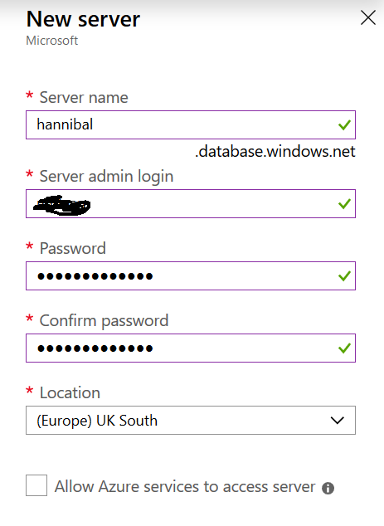
Press Ok when done.
The next options allow us to configure the database...
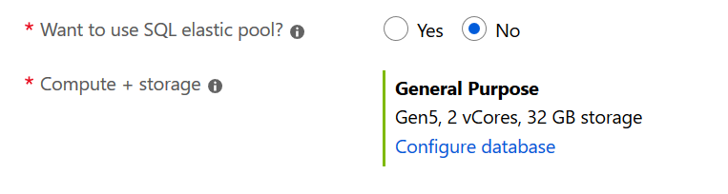
Leave SQL elastic pool at No and click the link to configure the database.
The option you want here is this one...
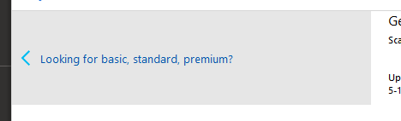
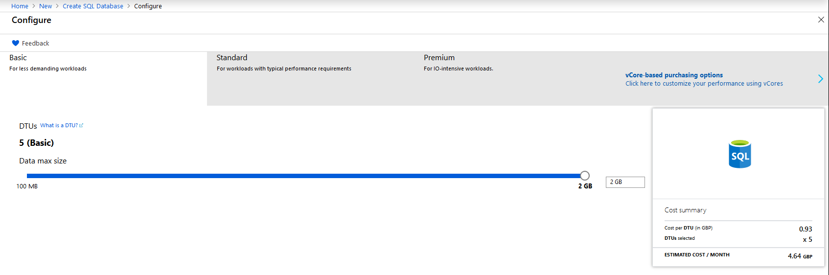
Once selected press apply...
You should see the following...
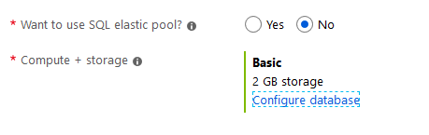
Next press additional settings...

Set up this page with the following options...
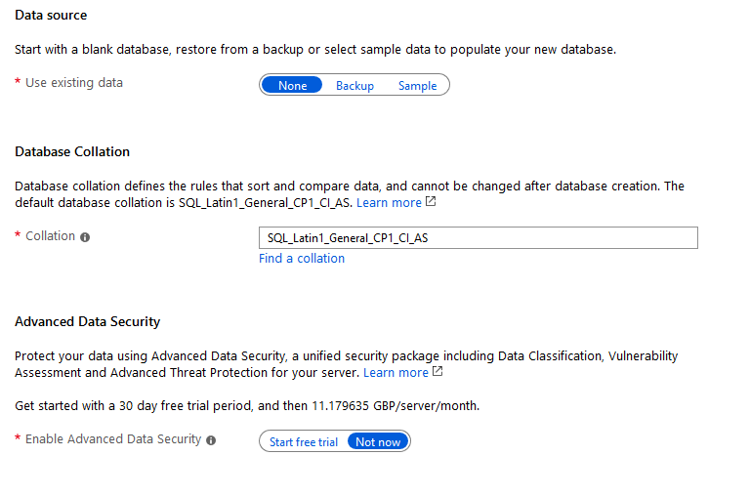
Press next : tags...

Leave the following page as it is...
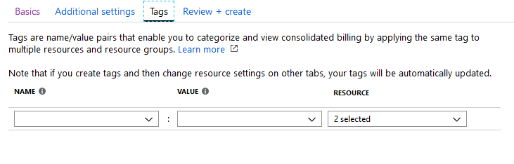
Press Review + Create....

The most important item on this page is to make sure you haven’t accidentally selected a super expensive pricing plan; it should look like this...
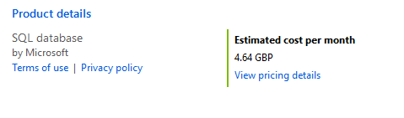
If it doesn’t then double check the setting or ask your tutor.
Lastly press create...

You should see activity notifications at the top right of the page...
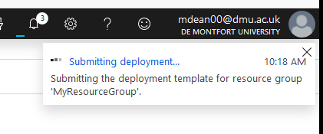
This process may take a little while.
(If you want something to do try hitting refresh a few times!)
Once the system is done you will be able to see your resources under “All resources”...
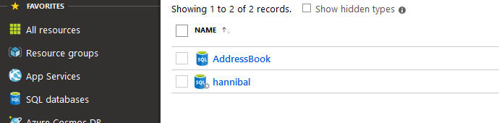
For the next step we need to access the database from Visual Studio, don’t close the portal yet as we may need to adjust some of the security settings.

Using Visual Studio as the Database Owner
Open Visual Studio and access the server explorer...
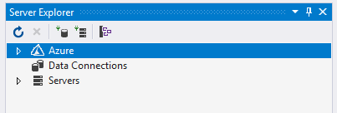
By selecting the correct tab at the bottom of the window...
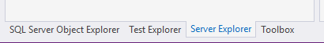
Right click on Azure and select the following...
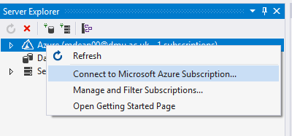
This will take you to the main login screen for Azure in Visual Studio...
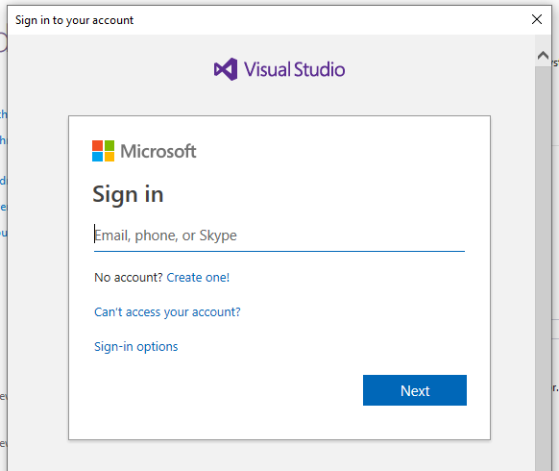
Once signed in you should be able to see your server and database in server explorer...
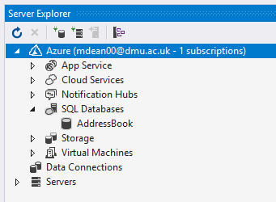

Checking the Connection
Right click on the database and select the following...
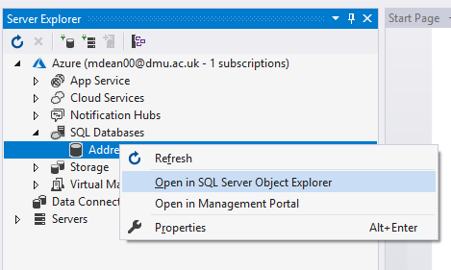
At this stage we have a good test to make sure that the firewall at Azure isn’t blocking access from our client machine.
You may encounter the following error...
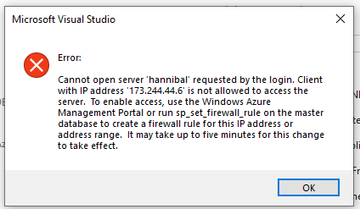
If this message appears you will need to go back to the Azure web portal and allow access for yor client machine.
Under all resources click on the server you created above...
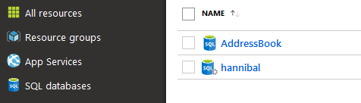
In the central menu find security and click on “Firewalls and virtual networks”...
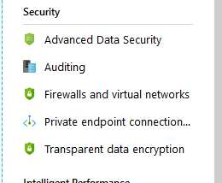
You should see the following screen...
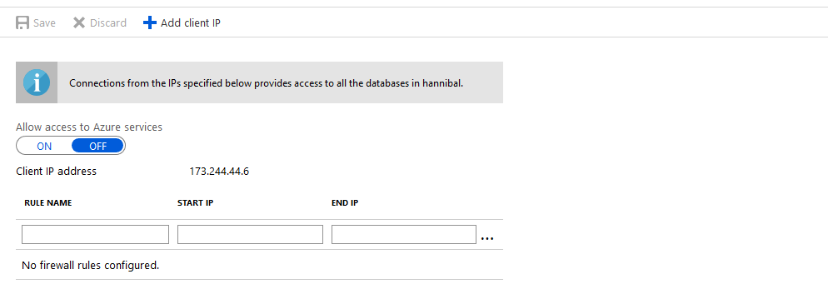
Press “Add client IP” to tell Azure that this local machine is allowed access, the client IP address will be added as a firewall rule...
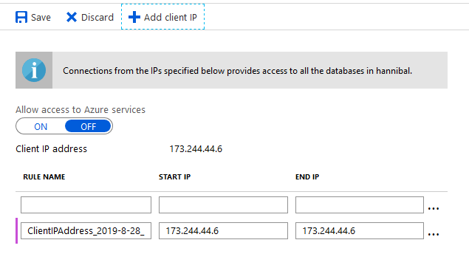
Next press save.

Accessing the Database for Other Team Members
The database owner will have access to the database as part of their Azure account. The main Azure account is accessed using your PNumber and University password, these details should not be given out to other team members!
For each team member to access the database they will need the name of the server, user name and password created above. (You should have made a note of this.)
In the SQL Server Object Explorer right click on SQL Server and click Add SQL Server...
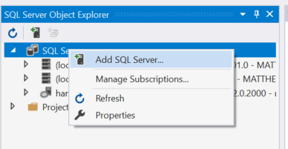
This will provide you with the following log in page...
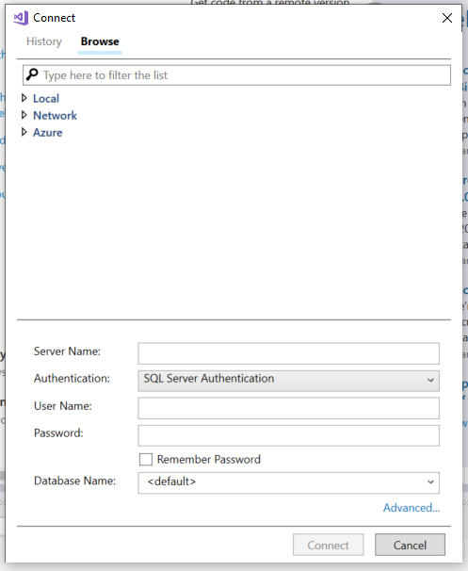
Make sure that authentication is set to SQL Server Authentication.
The Server Name will be something like {servername}.database.windows.net where {servername} is the name you have given your server.
User name and Password are those created by the server owner, and then press connect.
Try accessing the database through Visual Studio and you should now be able to navigate the structure...
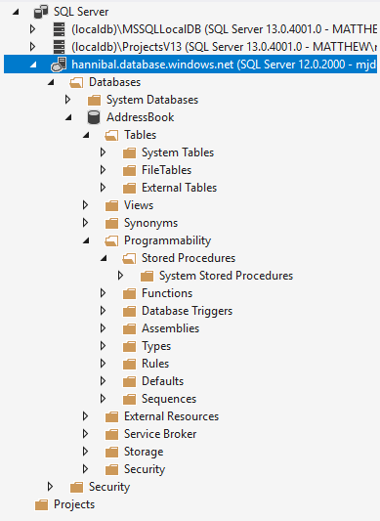
At this stage expand the sections for “Tables” along with “Programmability – Stored Procedures”

Creating Tables
The next resource we need to create is a table to store some data in.
From the SQL Server Object Explorer, right click on the section marked tables selecting “Add New Table”...
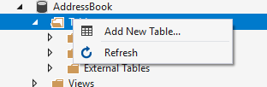
After a bit of waiting you will be presented with the following screen...
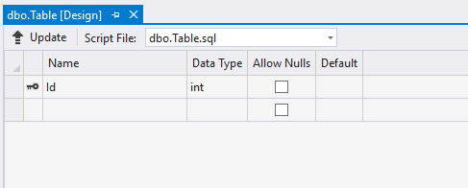
We will set up a basic table to store our list of counties.
First, set the name of the table by modifying the SQL at the bottom of the window setting the table name to tblCounty...
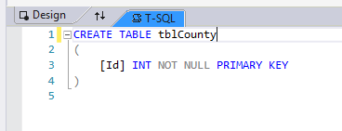
(“tbl” is just a naming table to remind us that this is a table!)
Next we will add the primary key. In the top window set up the first field like so...
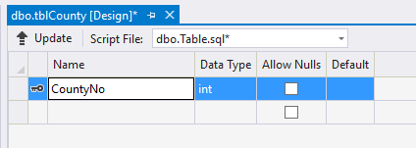
Next we need to set up the primary key so that it automatically increments every time we add a new record. To do this we need to set identity to true.
With the field still selected (in blue) access the properties for the field in the bottom right of the interface, switch “Is Identity” from false to true...
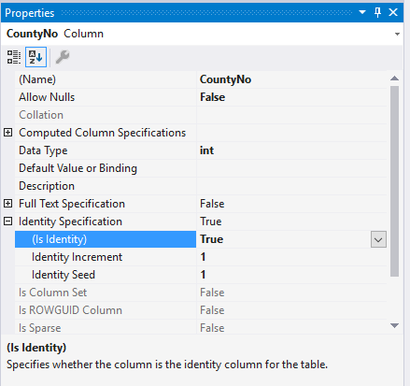
Lastly create the second attribute County like so...
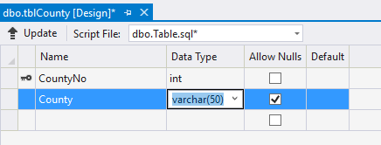
Watch out for nchar! If you want to store text based data varchar is a much better choice than nchar. Nchar produces fixed length strings that don’t always behave how you might expect.
To create the table you must press the button “Update”, if you don’t then the structure of the database will not be changed.
When you press update you will be presented with an preview screen like so...
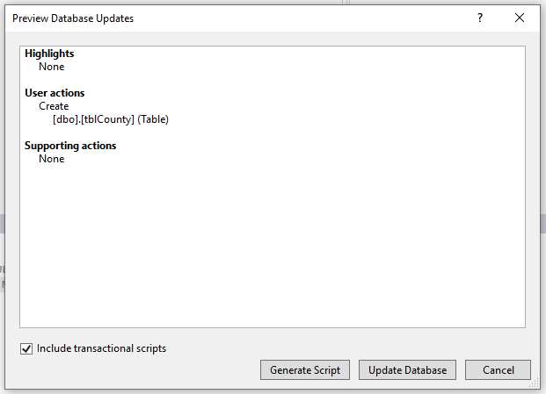
Assuming there are no errors press “Update Database”. You are looking for a green dot appearing once the table is created...
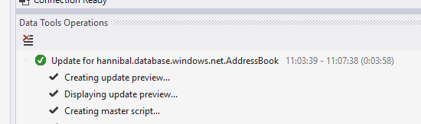
(It may take a while!)
Your table should now be visible, if not right click on the tables branch and select refresh...
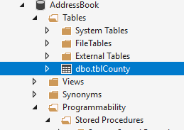

Adding Data
Now that we have created the structure of the table we need to add some data to the table.
To do this right click on the table and select View Data...
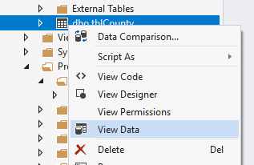
Rather than sitting typing all of these counties into the table I would suggest copying and pasting the records directly in to the table.
1 | Avon
2 | Bedfordshire
3 | Berkshire
4 | Buckinghamshire
5 | Cambridgeshire
6 | Cambridgeshire and Isle of Ely
7 | Cheshire
8 | City of Bristol
9 | City of London
10 | Cleveland
11 | Cornwall
12 | Cumberland
13 | Cumbria
14 | Derbyshire
15 | Devon
16 | Dorset
17 | Durham
18 | East Suffolk
19 | East Sussex
20 | Essex
21 | Gloucestershire
22 | Greater London
23 | Greater Manchester
24 | Hampshire (County of Southampton)
25 | Hereford and Worcester
26 | Herefordshire
27 | Hertfordshire
28 | Humberside
29 | Huntingdon and Peterborough
30 | Huntingdonshire
31 | Isle of Ely
32 | Isle of Wight
33 | Kent
34 | Lancashire
35 | Leicestershire
36 | Lincolnshire
37 | Lincolnshire, Parts of Holland
38 | Lincolnshire, Parts of Kesteven
39 | Lincolnshire, Parts of Lindsey
40 | London
41 | Merseyside
42 | Middlesex
43 | Norfolk
44 | North Humberside
45 | North Yorkshire
46 | Northamptonshire
47 | Northumberland
48 | Nottinghamshire
49 | Oxfordshire
50 | Rutland
51 | Shropshire (Salop)
52 | Soke of Peterborough
53 | Somerset
54 | South Humberside
55 | South Yorkshire
56 | Staffordshire
57 | Suffolk
58 | Surrey
59 | Sussex
60 | Tyne and Wear
61 | Warwickshire
62 | West Midlands
63 | West Suffolk
64 | West Sussex
65 | West Yorkshire
66 | Westmorland
67 | Wiltshire
68 | Worcestershire
69 | Yorkshire
70 | Yorkshire, East Riding
71 | Yorkshire, North Riding
72 | Yorkshire, West Riding

You should end up here...
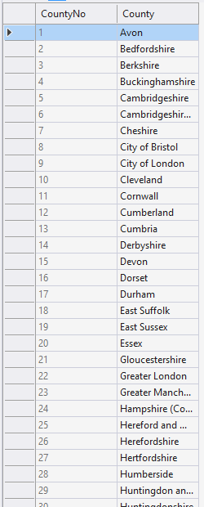
Close the table once the data has been pasted.

Creating Stored Procedures
As mentioned above we will not be accessing the table directly with our code but using a stored procedure. One of the biggest advantages of this approach is that of increased security.
Creating a stored procedure is a very similar process to creating a table.
In the SQL Object Browser right click on the stored procedure branch and select “Add New Stored Procedure...”
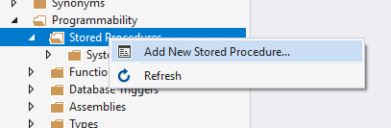
After a little while you should see the following screen appear...
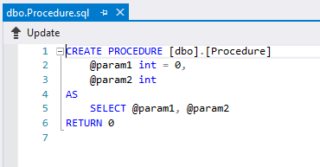
Modify the SQL code as follows...
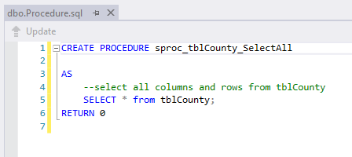
As in the case of a table you must press update to make the changes to the database structure.
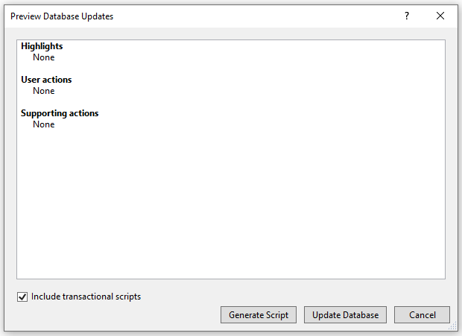
You should see the stored procedure in the tree structure of the database, if not try refreshing it...
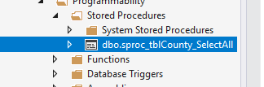

Testing the Stored Procedure
To make sure the stored procedure is working right click on it like so...
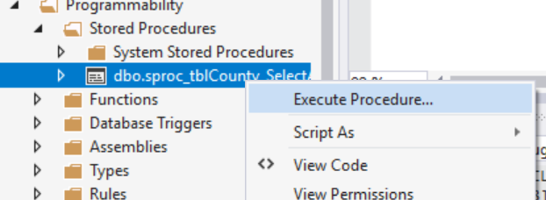
You should see the data from the underlying table displayed...
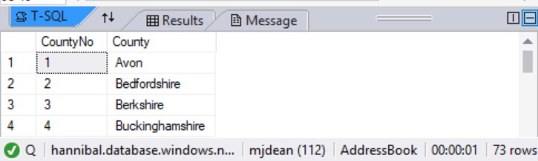
Close the query output window, don’t bother saving it.

Using the DataConnection
You should by this stage have a server set up on Azure, with a database called AddressBook, a table called tblCounty and a stored procedure called sproc_tblCounty_SelectAll...
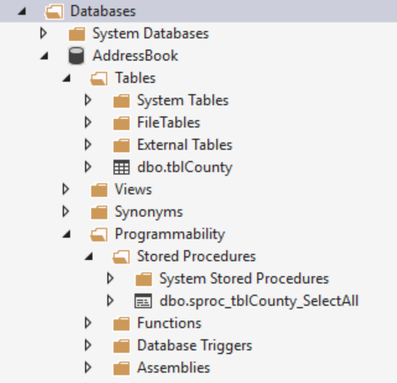
The table contains a list of UK counties…
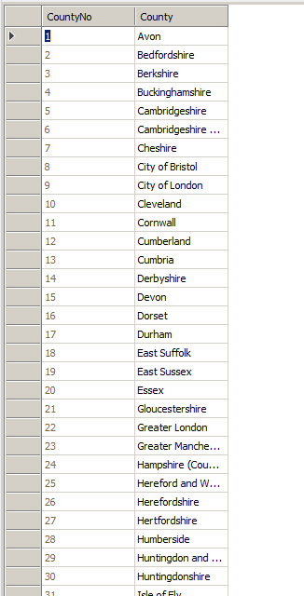
The stored procedure called sproc_tblCounty_SelectAll contains the following SQL…
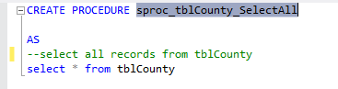

clsDataConnection
This class has been written for you to avoid you having to deal with the complexities of working with ADO.NET the technology used by Microsoft to link to the Azure SQL server database.
This example will take you through the features of the class and show you how to use the data from the table.

Creating the Data Connection Class File
To create the data connection class file right click on the App_Code folder and select Add – Class.
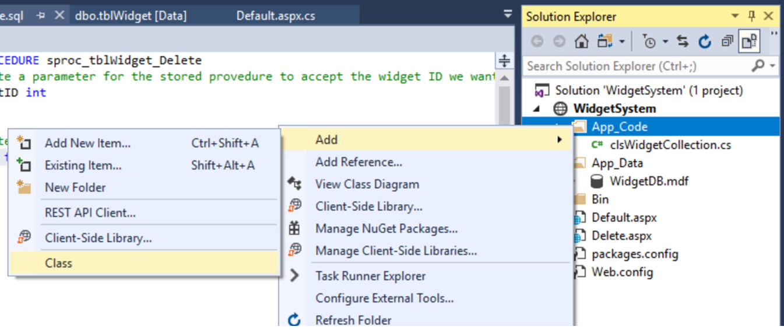
For the name of the class enter clsDataConnection
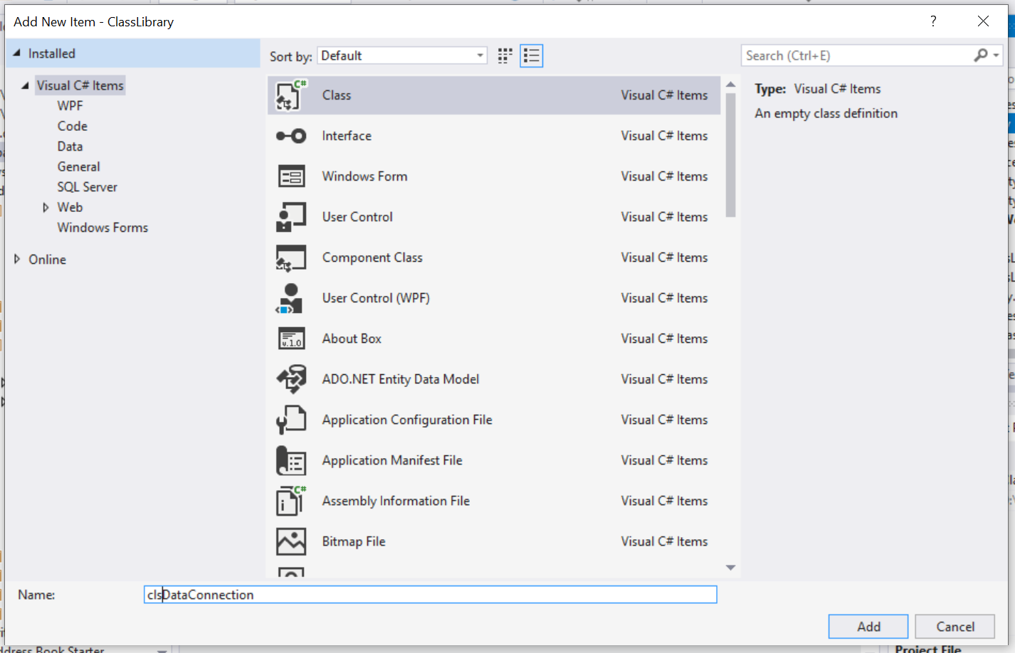
Press OK.
As with the first class it will create some code automatically in this case we want to replace it all.
Highlight the code in the class file created for you and delete it all.
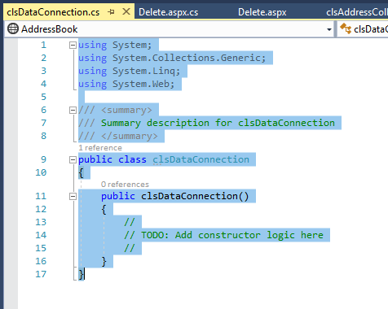
Next obtain the code for the class file from the module web site.
Paste it all into this blank class file...
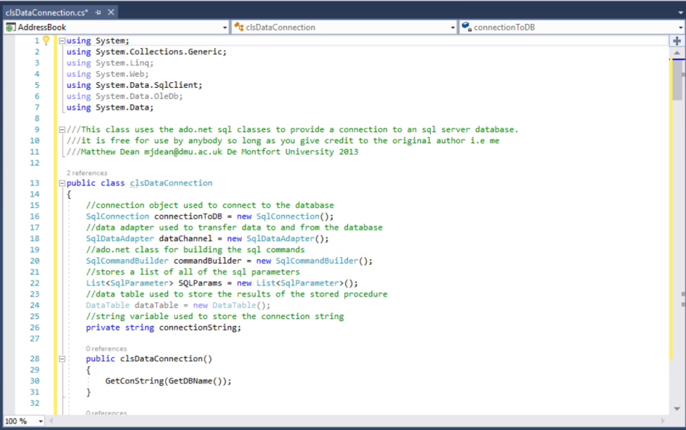
Close and save the class definition. It should be listed in the solution explorer.
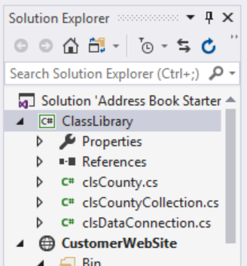

Azure Connect
In order for your code to connect to Azure we need to provide it with the name of your server, then name of your database, your username and password.
If you look at the settings in the Azure Portal for your database...
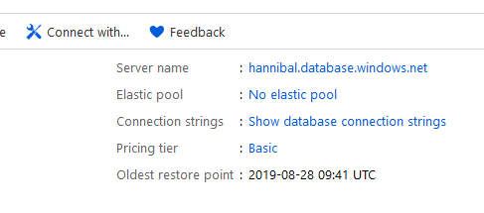
You will see a section for connection string, which will look something like this...

Connection Strings and Public Git Repositories
In order for this to work you need to replace the sections marked {username} and {password} with your own credentials.
So here is the problem. If you add this code into your data connection and place it into a public repository, your plain text user name and password is visible for all to see.
Even if you were using a private repository it likely still isn’t a good idea to store these details as plain text.
To get around this problem a program has been written called Azure Connect, available from the module web site.
When you run the program you will see the following interface...
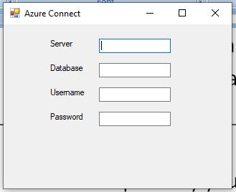
Enter here the details required by each field...
